**Chemistry 12 Task 9 Proteins Investigation**

Complete this assignment at home. There will be a Validation Test on Wednesday 8 September 2021.

Watch this TED Talk on Protein: <https://www.youtube.com/watch?v=zm-3kovWpNQ>

Below is a table listing the three major categories of Amino Acids. They can be non-polar, polar or electrically charged. Proteins are merely a string of amino acids bound together. The polarity of an amino acid determines how the protein folds and in biology structure determines function. The shape of a protein determines the functions it can perform. Protein science could solve indigestion problems or immune disorders. You are going to research this fascinating topic to gain a deeper understanding about protein science.

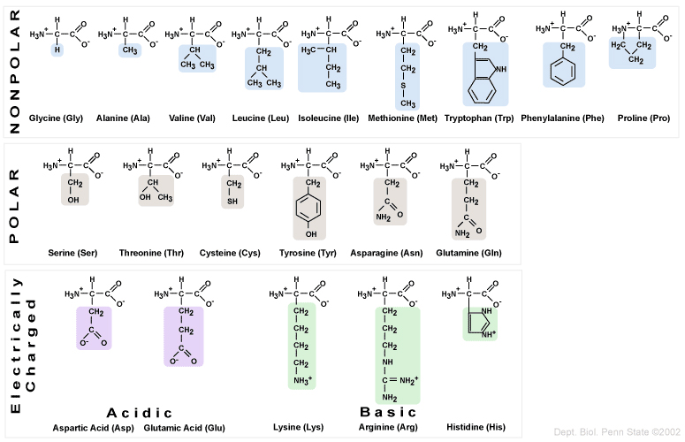

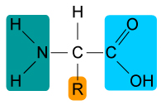Starting at the beginning…

1. What functional groups are found in all amino acids? **(1, ½ each)**

i._______________________________________

ii._______________________________________

1. What is an alpha amino acid? How can you identify an alpha amino acid? **(2 marks)**

_______________________________________________________________________________________________

_______________________________________________________________________________________________

_______________________________________________________________________________________________

1. a) What is a zwitterion? Can amino acids form zwitterions? **(2 marks )**

____________________________________________________________________________________________

____________________________________________________________________________________________

_______________________________________________________________________________________________

_______________________________________________________________________________________________

b) Use alanine to show what its zwitterion looks like. **(2 marks )**

↔

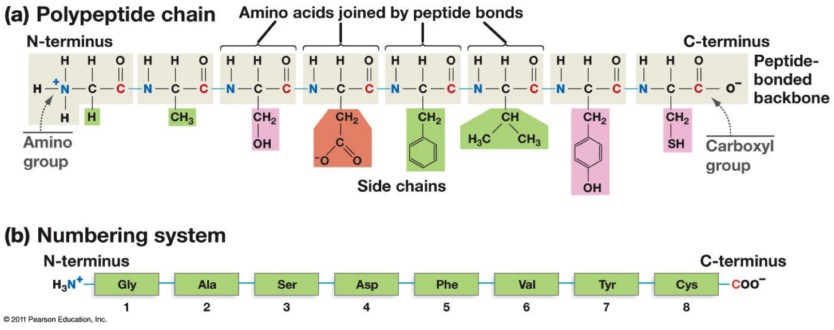

1. Refer to your data booklet for the structural formula of alanine, one of the simplest amino acids. Use two alanine molecules to depict how a peptide bond can form. Show all the products of this bond formation. **(2 marks)**
2. A string of amino acids held together by peptide bonds is known as the primary structure of a protein. Proteins fold to form their functioning shape.
3. Secondary structure of protein folding: State the two different types of secondary folding, their shape and the type of bonding that holds them together. **(3 marks)**

_______________________________________________________________________________________________

_______________________________________________________________________________________________

_______________________________________________________________________________________________

_______________________________________________________________________________________________

_______________________________________________________________________________________________

_______________________________________________________________________________________________

_______________________________________________________________________________________________

_______________________________________________________________________________________________

_______________________________________________________________________________________________

1. Tertiary Structure: Describe how proteins maintain their tertiary structure and state which type of amino acids tend to fold toward the inside of the protein and which type of amino acids are more likely to be found on the exterior of the protein. **(3 marks)**

_______________________________________________________________________________________________

_______________________________________________________________________________________________

_______________________________________________________________________________________________

_______________________________________________________________________________________________

_______________________________________________________________________________________________

_______________________________________________________________________________________________

_______________________________________________________________________________________________

_______________________________________________________________________________________________

_______________________________________________________________________________________________

1. Disulfide bonds can help hold a protein together. What is a disulfide bond and what amino acid is involved? **(2 marks)**

_______________________________________________________________________________________________

_______________________________________________________________________________________________

_______________________________________________________________________________________________

_______________________________________________________________________________________________

_______________________________________________________________________________________________

_______________________________________________________________________________________________

_______________________________________________________________________________________________

_______________________________________________________________________________________________

1. Does pH affect protein structure? If it does then what is the reason why it affects protein structure? **[4 ]**

_______________________________________________________________________________________________

_______________________________________________________________________________________________

_______________________________________________________________________________________________

_______________________________________________________________________________________________

_______________________________________________________________________________________________

_______________________________________________________________________________________________

_______________________________________________________________________________________________

_______________________________________________________________________________________________

_______________________________________________________________________________________________

_______________________________________________________________________________________________

_______________________________________________________________________________________________

_______________________________________________________________________________________________

1. What other factors denature a protein by changing the way a protein folds? Briefly explain why these factors affect protein folding**. ( 4 marks)**

_______________________________________________________________________________________________

_______________________________________________________________________________________________

_______________________________________________________________________________________________

_______________________________________________________________________________________________

_______________________________________________________________________________________________

_______________________________________________________________________________________________

_______________________________________________________________________________________________

1. Use the data booklet which lists the various amino acids and their side groups to determine which amino acids can experience the following type of intermolecular bonding:
2. Salt bridge (ionic bonding): ( **2 marks,** - ½ for each missing or incorrect amino acid)

______________________________________________________________________________

______________________________________________________________________________

______________________________________________________________________________

Draw an example of a salt bridge (1)

1. Hydrogen bonding ( **2 marks,** - ½ for each missing or incorrect amino acid)

______________________________________________________________________________

______________________________________________________________________________

Draw an example (1)

1. Dipole-dipole attraction: ( **2 marks,** - ½ for each missing or incorrect amino acid)

______________________________________________________________________________

______________________________________________________________________________

Draw an example: (1)

1. Dispersion forces only: ( **2 marks,** - ½ for each missing or incorrect amino acid)

______________________________________________________________________________

______________________________________________________________________________

Draw an example (1)

1. What is the worldwide Protein Data Bank? What type of data about proteins (be specific) does it store? If you use a term you do not know then be sure to provide an explanation for this term. **[ 5 marks ]**

_______________________________________________________________________________________________

_______________________________________________________________________________________________

_______________________________________________________________________________________________

_______________________________________________________________________________________________

_______________________________________________________________________________________________

_______________________________________________________________________________________________

_______________________________________________________________________________________________

_______________________________________________________________________________________________

_______________________________________________________________________________________________

_______________________________________________________________________________________________

_______________________________________________________________________________________________

1. What is the main purpose of the Protein Data Bank? **[2 marks]**

_______________________________________________________________________________________________

_______________________________________________________________________________________________

_______________________________________________________________________________________________

_______________________________________________________________________________________________

_______________________________________________________________________________________________

_______________________________________________________________________________________________

1. Use the inherited disease sickle-cell anaemia as an example to illustrate your understanding of how the primary structure of a protein determines the tertiary structure of the protein, and how this in turn determines the function of the protein.

_______________________________________________________________________________________________

_______________________________________________________________________________________________

_______________________________________________________________________________________________

_______________________________________________________________________________________________

_______________________________________________________________________________________________

_______________________________________________________________________________________________

_______________________________________________________________________________________________

_______________________________________________________________________________________________

_______________________________________________________________________________________________

_______________________________________________________________________________________________

_______________________________________________________________________________________________

_______________________________________________________________________________________________

_______________________________________________________________________________________________

_______________________________________________________________________________________________

_______________________________________________________________________________________________

_______________________________________________________________________________________________